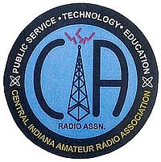
Hamilton County Amateur Radio Emergency Service, Inc., d/b/a

Central Indiana Amateur Radio Association

Membership Form
Call sign: ___________________________________ Date: _______________________
Name: _________________________________________________________________
Address: _______________________________________________________________
City, State, ZIP: __________________________________________________________
Phone(s): _______________________________________________________________
E-mail address: __________________________________________________________
Check this box to be added to the HCARES/CIARA email group (n9eoc@googlegroups.com). You can unsubscribe at any time.
Are you an ARRL member? _______________
Dues year / amount:
- New members (first year) – free
- Individual - $20.00
- Family - $30.00
- Student K-12 - $5.00
Please send dues to the Treasurer (Paul, KA9SDQ) or bring them to the next meeting. Checks may be made payable to “HCARES” or “CIARA.”

